Research at the Speed of Thought: Augmented Data as the Engine of Agile Insights

WIN ASSOCIATION
Richard Colwell, Laura Ruvalcaba & Edouard Lecerf

Abstract
This paper assesses the accuracy of three AI-driven augmented data models—Lite, Express, and Full (N-Infinite)—under two mixing scenarios (50/50 and 70/30 real vs. synthetic) across five diverse markets (Mexico, France, UK, USA, Indonesia). Using nationally representative micro-census profiles and real survey responses, we generated both fully synthetic and hybrid datasets and evaluated them via significance tests and correlation analyses against 100% human data. We found that models at 30% synthetic offer the highest fidelity.

Structure of the Paper

Introduction
  - Background
  - Problem Statement

Study Objectives and Research Questions
  - Study Objectives
  - Research Questions

Theoretical and Methodological Foundations
  - Synthetic Data vs. Augmented Data
  - Benefits and Risks of Using Synthetic Data

Methodology
  - Data Sources
  - Synthetic Data Generation Models
  - Relevant Statistical Techniques and Predictive Models

Results
  - Overall Accuracy Across All Five Markets
  - Country-by-Country: Augmented Data
  - Country-by-Country: Hybrid Data

- Survey Output Comparison

Introduction

Background

In recent years, the generation of synthetic data has emerged as a powerful solution to many of the challenges faced by traditional survey- and transaction-based studies. By leveraging machine-learning algorithms, organizations can create large volumes of high-fidelity data that mimic the statistical properties of real observations without exposing any individual’s personal information. This capability is particularly valuable for deepening insights into population behavior, training predictive models, and stress-testing analytics pipelines when original datasets are in short supply or too sensitive to share. From a methodological standpoint, synthetic data can be produced in a fully generative way or—as this paper emphasizes—via augmented data approaches that enrich an existing sample by algorithmically filling in missing or under-represented segments.

Problem Statement

Despite the promise of synthetic data, organizations still rely heavily on 100% human data, collected through face-to-face interviews, online panels, and administrative records. These classical methods face several critical limitations:
    - Cost: Deploying large-scale surveys, especially across multiple countries, entails substantial fieldwork expenses, interviewer training, and data-processing overhead.
    - Time: The cycle from questionnaire design to clean dataset delivery can span weeks or even months, delaying decision making.
    - Privacy: With growing regulations and heightened public concern, sharing sensitive microdata is increasingly fraught.
By focusing on augmented data—where a subset of real observations is combined with algorithmically generated responses—we aim to alleviate the high cost and long timelines inherent in traditional data collection, while still preserving analytical validity.

Study Objectives and Research Questions

Study Objectives

The primary objective of this study is to evaluate the accuracy of AI-generated augmented data
for replacing or complementing 100% human data in multi-country survey applications.

Specifically, we compare three distinct augmentation methodologies (Lite, Express, and Full/N-Infinite) under two mixing scenarios (50% real and 50% synthetic; 70% real and 30% synthetic) across five countries' datasets.
Throughout this paper, “real data” will be referred to as 100% human data, algorithm-generated outputs as AI-Augmented data and the data set composed of real data + AI-Augmented data will be referred to as Hybrid data.

Research Questions

To steer this study, we articulate two primary research objectives:

Identify which augmentation model achieves the highest accuracy relative to 100% human data.
We compare the three AI-driven approaches—Lite, Express, and Full—by measuring the share of variables that exhibit no statistically significant difference versus entirely human‐collected data. This overall fidelity metric reflects each model’s capacity to reproduce the original survey’s demographic and response distributions.

Determine which model best replicates question-level outcomes in hybrid datasets.
Beyond aggregate fidelity, we evaluate how closely each hybrid dataset (a mix of real and AI-generated records) mirrors the actual survey responses on an item-by-item basis. This analysis examines whether the patterns, distributions, and inter-variable correlations present in the original data are preserved consistently across countries and demographic groups.

Theoretical and Methodological Foundations

Synthetic Data vs. Augmented Data

Before getting into the project, it is worth a brief explanation on key concepts.

Synthetic data refers to information that is artificially generated rather than collected from real-world observations. These data are created using mathematical models, simulations, or machine learning algorithms that replicate the statistical properties and relationships found in actual datasets. The goal is to produce data that resemble real data, while avoiding privacy concerns and enabling large-scale simulations or testing.
In contrast, augmented data, instead, is generated supported by an existing dataset—usually based on human data—producing records that are algorithmically predicted, imputed, or

extrapolated. These additions are designed to enrich the original dataset, fill gaps, or balance underrepresented subgroups.

Ensuring Consistency in Profiling Structure
To ensure consistency in sample composition across datasets, the synthetic data generation process was guided not only by the training subset of real data (either 50% or 70% of the original sample, using the full questionnaire) but also by providing the profiling variables (e.g., demographics) from the remaining portion of the real dataset. In other words, while only part of the records were used to train the model, complete profiling data from the entire original sample was included. As a result, the synthetic responses generated for the holdout portion were conditioned on real demographic profiles, ensuring that the resulting hybrid datasets (real + synthetic records) matched the full original sample in terms of profiling variable distributions. This approach was essential to isolate the impact of synthetic generation on response content, avoiding confounding effects related to changes in sample composition.

Benefits and Risks of Using Synthetic Data

The use of synthetic and augmented data offers a range of advantages:

    - Cost and Time Eﬃciency: Eliminates the need for extensive fieldwork and reduces delays associated with traditional data collection.
    - Scalability: Enables rapid expansion of datasets across segments or geographies.
    - Privacy Protection: Reduces the risk of disclosing personally identifiable information (PII), which is crucial in regulated environments.
    - Balanced Datasets: Can correct imbalances or sparsity in underrepresented groups, improving model fairness and generalizability.
However, there are also risks and limitations:

    - Loss of Authenticity: Poorly generated synthetic data may fail to capture real-world nuances, leading to misleading conclusions.
    - Overfitting and Artifacts: Models trained on synthetic data may overfit to patterns that do not generalize well to real-world applications.
    - Validation Complexity: It is often challenging to determine whether synthetic data adequately replicates the behavior of real populations, especially in high-dimensional spaces.

Methodology

Data Sources

This study was conducted using real survey datasets collected from five countries—Mexico, France, the United Kingdom, the United States, and Indonesia—participating in the WIN World Survey 2025, a global initiative aimed at measuring public opinions on major societal topics. These countries were selected based on regional diversity, allowing the evaluation of synthetic methodologies across a range of cultural and demographic profiles.

The original 100% human datasets included a combination of:
- Sociodemographic variables (e.g., gender, age, education level, region)
- Household indicators (e.g., pet ownership, housing type)
- Attitudinal and behavioral responses across various survey topics (e.g., health, technology, equality)
These datasets provided a representative snapshot of each country’s population, serving as a robust foundation for generating augmented data.

Each country contributed a dataset based entirely on real human responses with 1000 interviews for all countries except for Mexico with 800 respondents.

Profiling variables

Seven profiling variables were a target quota for each countries’ complete data set. In order to get this final quota, these were used to train supervised models that predict the remaining responses in the dataset. An example of the variables were:
- Age
- Gender
- Education Level
- Employment status
- Family situation

Synthetic Data Generation Models

Overview of Augmentation Methodologies
Three models were considered in this study by Livepanel (a Synthetic Data supplier based in Argentina): Lite, Express and Full (N-Infinite). These methodologies differ in the amount of real data they require, the complexity of their modeling frameworks, and their potential for fidelity and scalability.

Lite Methodology: Utilizes limited profiling data and lightweight predictive models to rapidly generate augmented records. Prioritizes speed over depth, with moderate accuracy.
Note: We ultimately decided to drop the Lite model from our workflows because it consistently failed to produce the volume of high-quality synthetic cases we required. Despite its faster runtime and lower data demands, it could not scale up to the sample sizes needed for robust subgroup analysis, leading to gaps in key segments.
Express Methodology: Leverages real census microdata to simulate plausible demographic profiles and fill in missing observations. Emphasizes distributional realism and representativeness.
Full Methodology (N-Infinite): Employs complex supervised learning models trained on real data to predict full questionnaire responses for partially observed cases. Involves cross-validation, ensemble techniques (e.g., random forests, gradient boosting), and behavioral profiling.
Profiling variables were used to predict the questionnaire responses with full methodologies, however these variables were insufficient to predict an accurate predictive quality. Therefore, the final setup used the first two questionnaire responses from real data to support the model, in addition to profiling variables.

Selection of the Base Dataset for Augmentation
In each case, a carefully cleaned and representative human dataset was selected as the base for augmentation. This selection followed strict procedure and quality checks:
- Procedure: The data provided to the supplier as input for AI generation were selected
based on their production date. Specifically, the first 50% of responses to the questionnaires were used to train the 50% augmented data, and the first 70% were used to train the 30% augmented data.
- We ensured we had:
  - Completion of profiling variables
  - Adequate distribution across geographic segments

Relevant Statistical Techniques and Predictive Models

To evaluate the accuracy and reliability of the synthetic data generated for the WIN 2025 survey across five countries, two main statistical validation approaches were implemented. These were applied under two training scenarios: (1) using 50% of the original dataset to train the synthetic model and generate the remaining 50% of records, and (2) train with 70% of real data and generate the remaining 30% synthetically. In both scenarios, the generation of the synthetic data was based on targeted demographic profiles.
The evaluation of accuracy level was conducted according to two core criteria: significance of differences in responses, and significance of differences in correlations within each data set.

Significance of Differences in Responses
We assessed whether there were statistically significant differences between the synthetic data and the real data (both holdout data and the full real dataset), for the total sample and across key demographic subgroups (gender and age range). Depending on the type of variable, the following tests were used, all with a significance level of 0.05:
  - Binary variables: z-test for proportions
  - Categorical variables: Chi-square test for homogeneity
  - Ordinal variables: Mann–Whitney U test
  - Numerical variables: Student’s t-test for difference in means These tests were applied in two comparison setups:
- Synthetic vs. Real Holdout Data: Comparing the synthetic data to the portion of real data not used in model training, representing the expected target for replication.
- Hybrid vs. Full Real Data: Comparing hybrid datasets (real + synthetic records) against the complete original dataset (including both training and holdout samples).

Significance of Differences in Correlations
To assess the preservation of underlying relationships between variables within each data set, Spearman correlation coefficients were calculated among all ordinal, binary, and numerical variables.
The statistical significance of differences in correlations between datasets was tested using Fisher’s z-transformation followed by z-tests for difference in correlation coeﬃcients, with a significance threshold of 0.05.
These correlation tests were also applied under both comparison frameworks (synthetic- only vs. real holdout; hybrid vs. full real) to ensure a comprehensive evaluation of structural fidelity in the generated data.

Results

  - Comparison of ONLY Augmented data versus Real data by Parity Score /% of variables with no significant differences)

Country-by-Country: Augmented Data - PARITY SCORE (% OF VARIABLES WITH NO SIGNIFICANT DIFFERENCE)

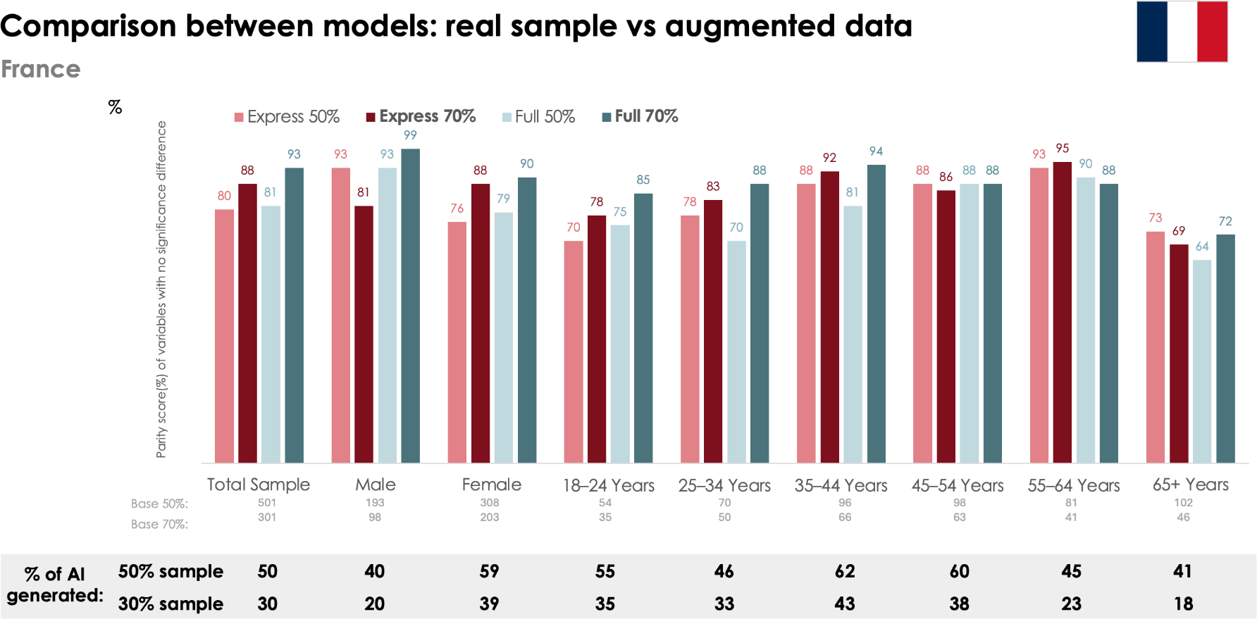

- Observation: Full 70% remains the top performer.

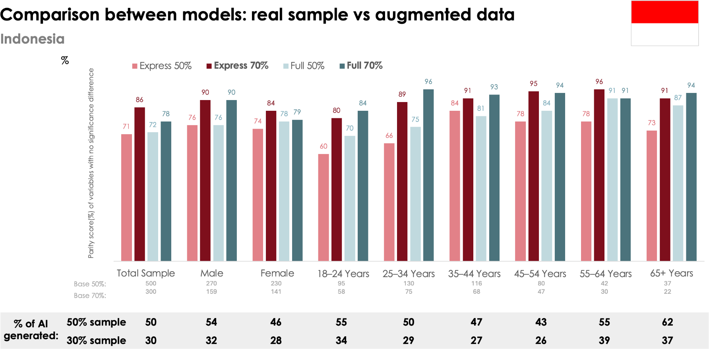

- Observation: Express 70% shows the best performance, followed by Full 70%.

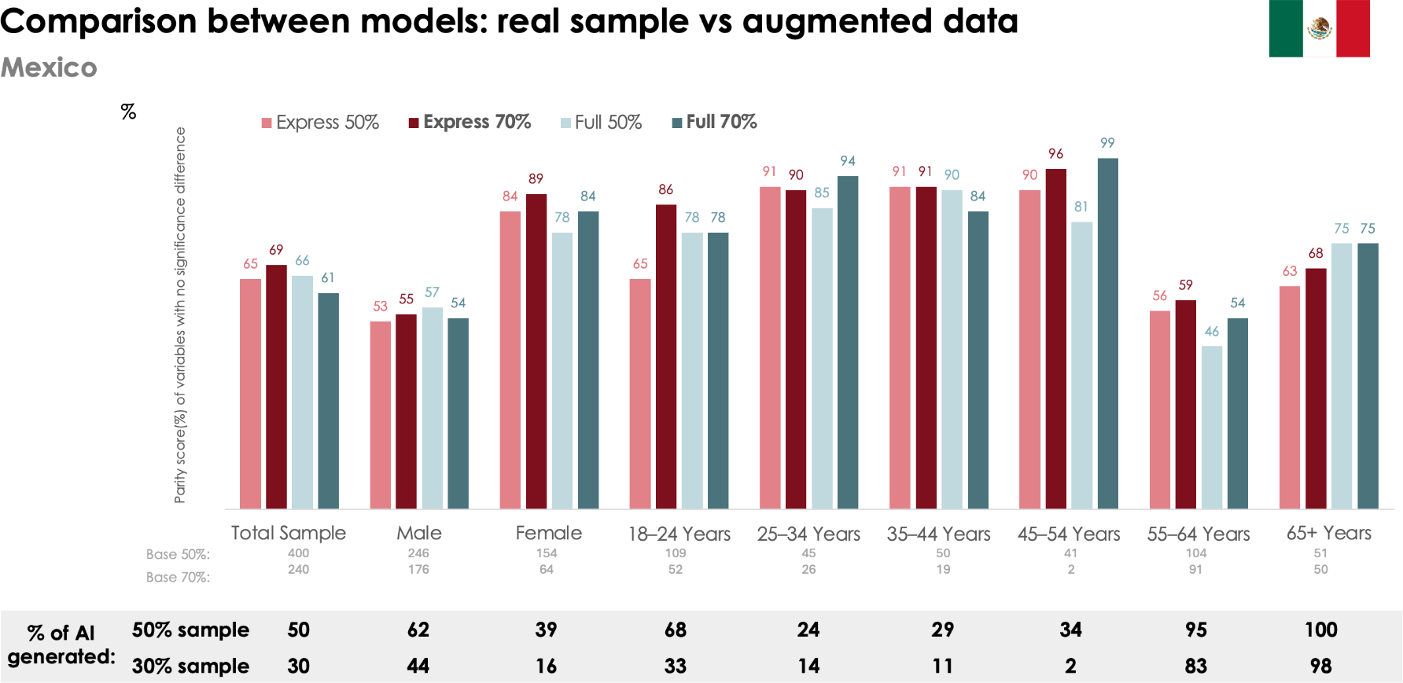

- Observation: Express (especially 70%) performs unusually well in the augmented-only data, even better than Full in some cases.
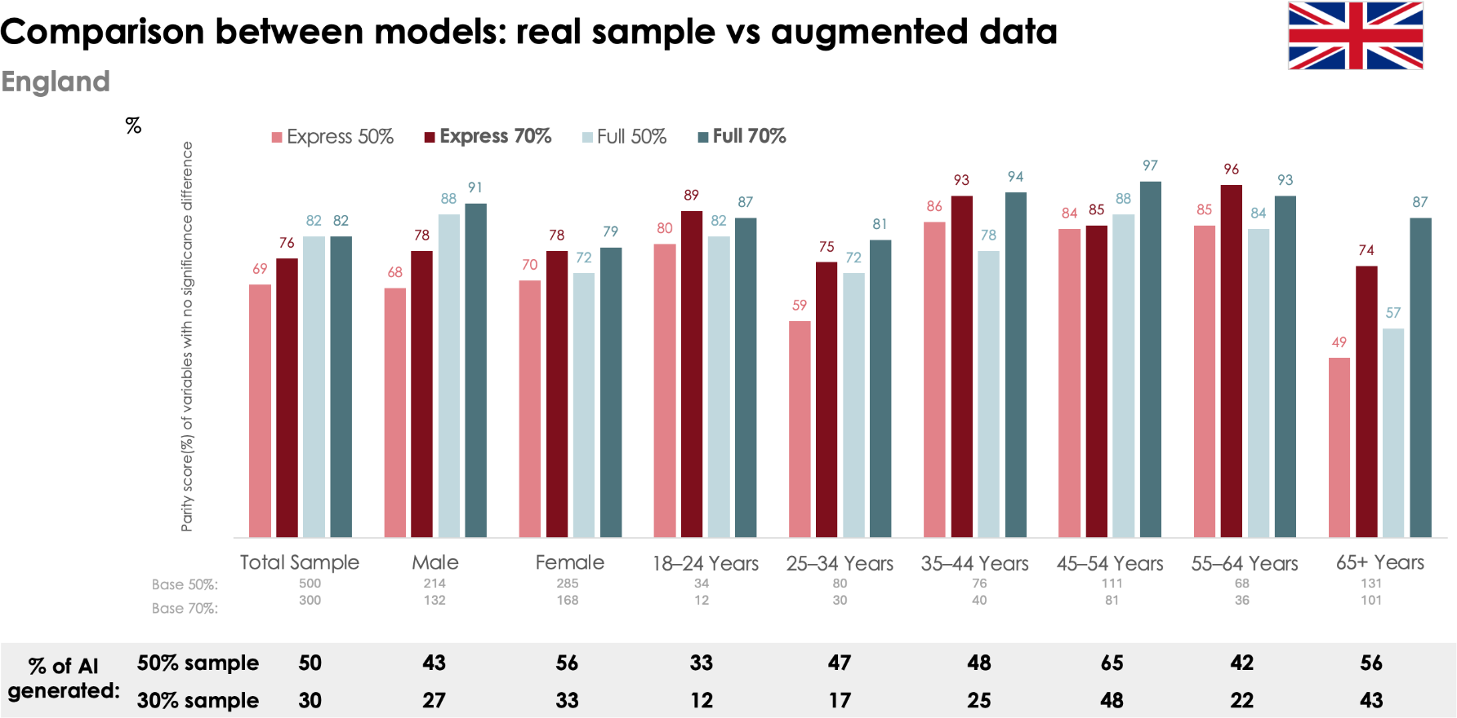

- Observation: Full 70% clearly outperforms other models.

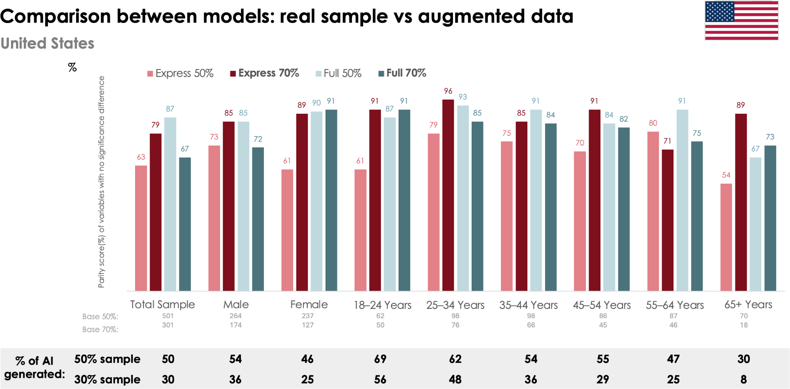

- Observation: Express 70% performs surprisingly well, and Full 50%.

  - Comparison of HYBRID data versus Real data by Parity Score /% of variables with no significant differences)

Country-by-Country: Hybrid Data - PARITY SCORE (% OF VARIABLES WITH NO SIGNIFICANT DIFFERENCE)

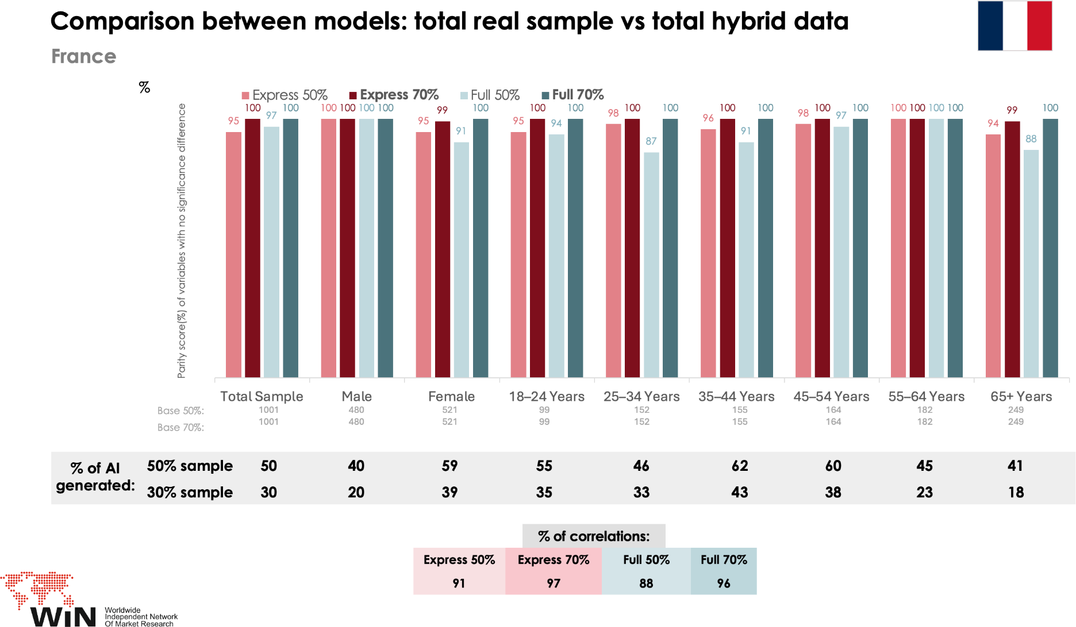
- Observation: Full 70% leads, but Express 70% is very close on estimations.
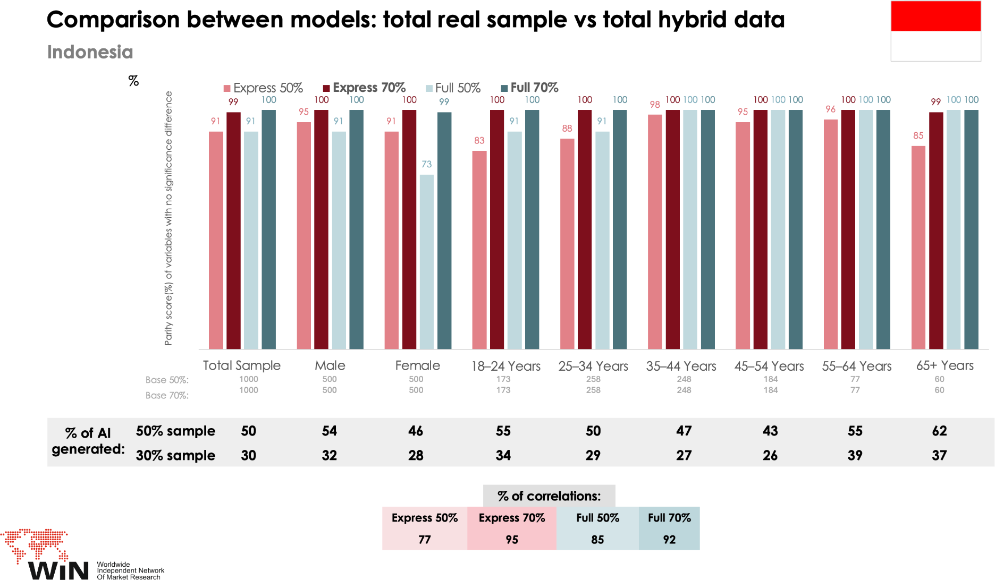
- Observation: Full 70% again leads, with Express 70% close behind.

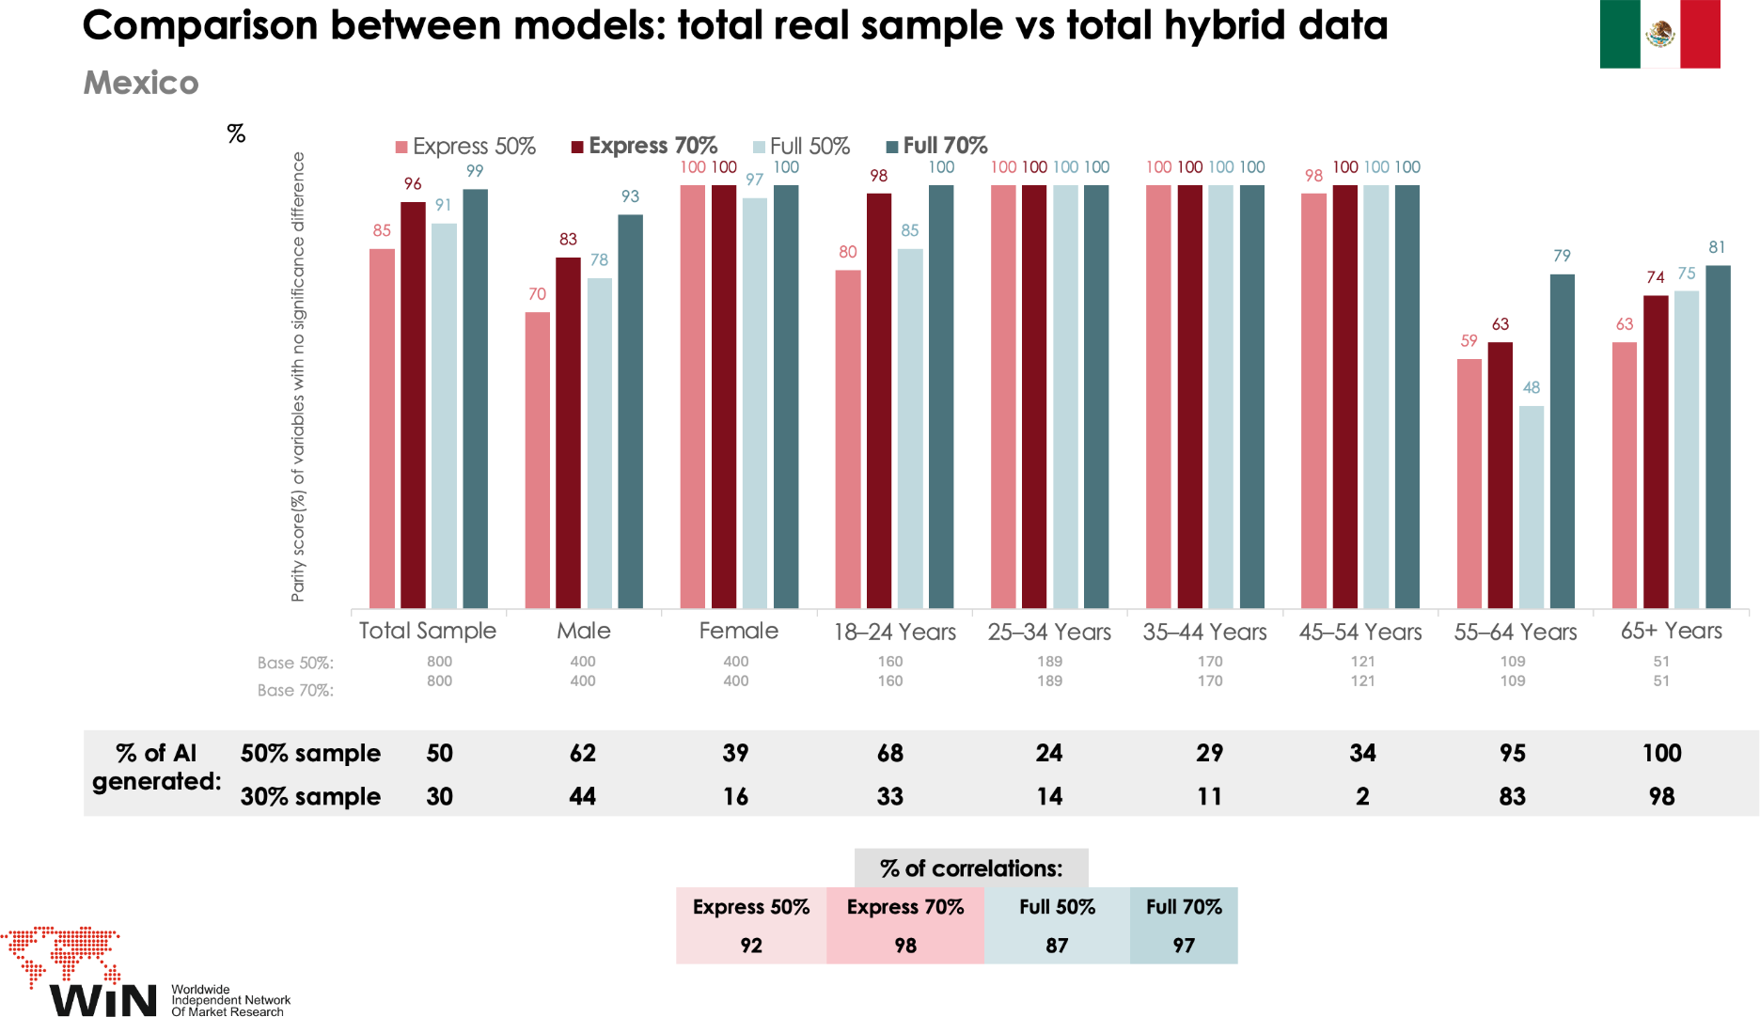

- Observation: Full 70% achieves the highest estimation with real data.

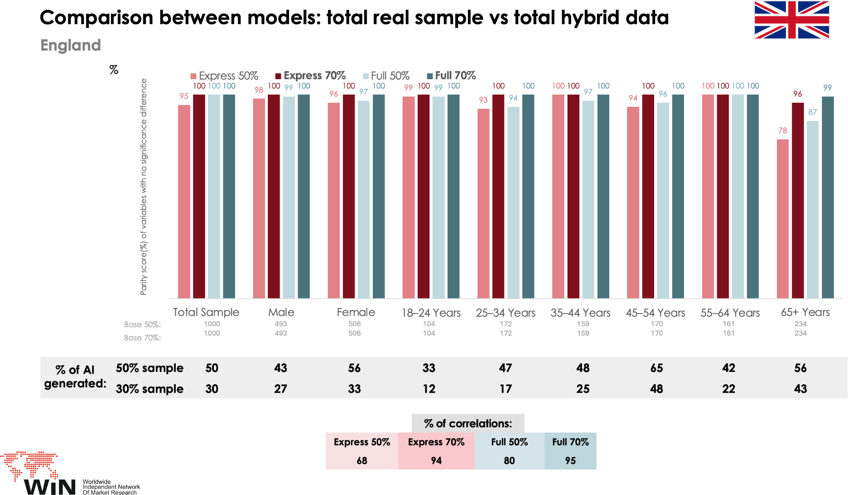

- Observation: performance trends remain similar—Full 70% and Express 70% are the best..

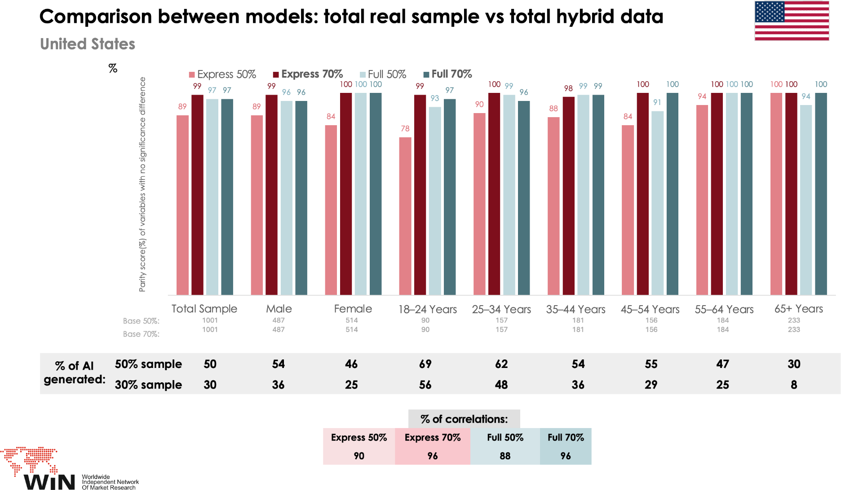
- Observation: Express 70% performs better.

Summary of Trends Across All Countries

Country | Best Hybrid Data Model | Best Augmented Data Model | Comments
France | Full 70%, Express  70% | Full 70% | Good estimation from models
Indonesia | Full and Express 70% | Express 70%, Full  70% | Good estimation from models
México | Full 70%, Express  70% | Express 70% | Data insufficiency makes the models struggle for older age segments and male.
UK | Full 70% and  Express 70% | Full 70% | Good estimation from models
USA | Express 70% | Express 70% and  Full 50% | Good estimation from models

¿What about the results of the output of the survey comparing Hybrid data versus Real data?

Survey Output Comparison
  - Question 1: At what age does someone starts feeling old?
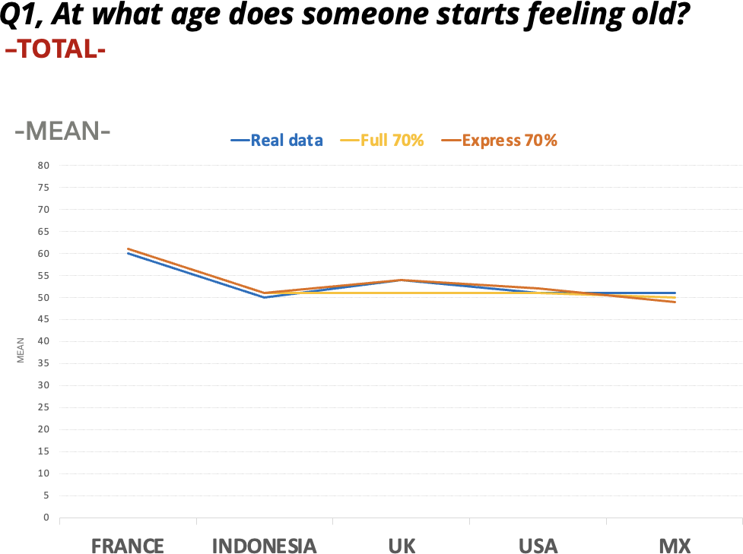

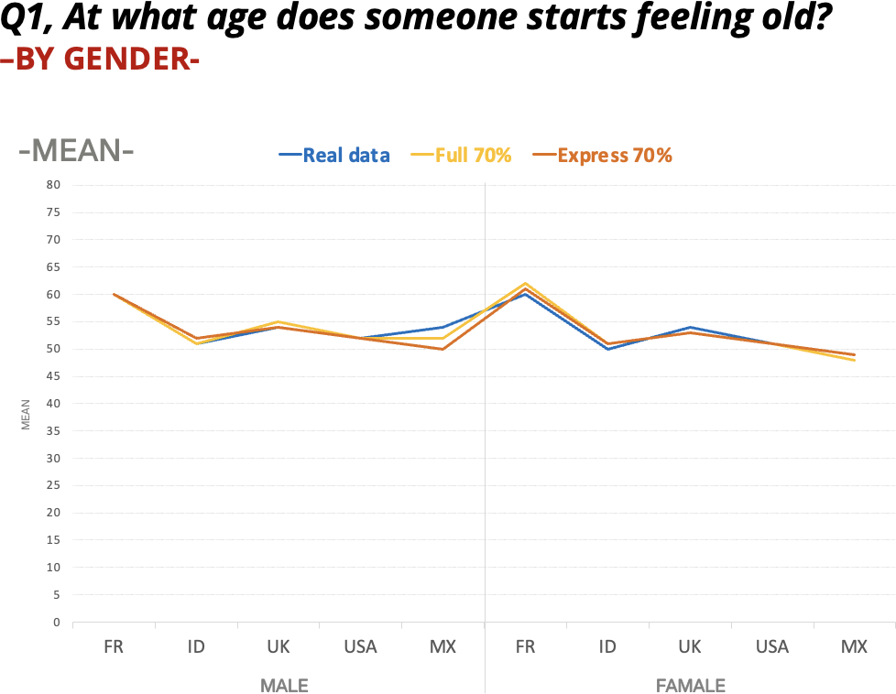
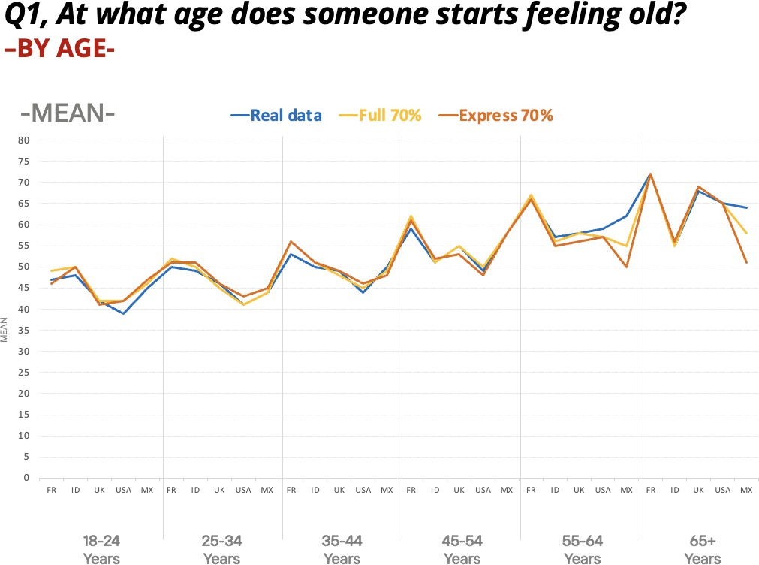

  - Question 2: Do you plan on having children later on?

    - Yes, and I don’t have children
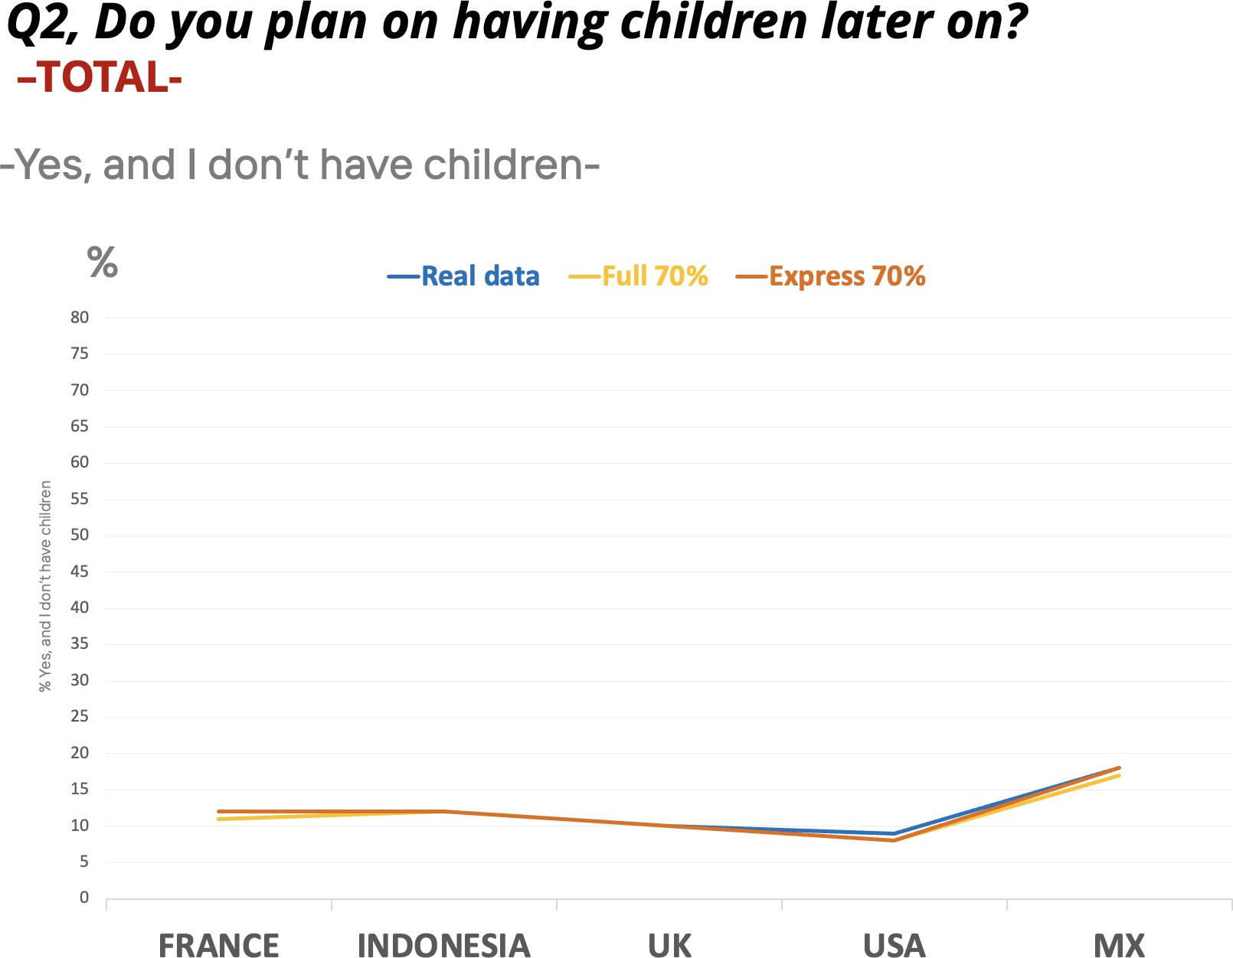
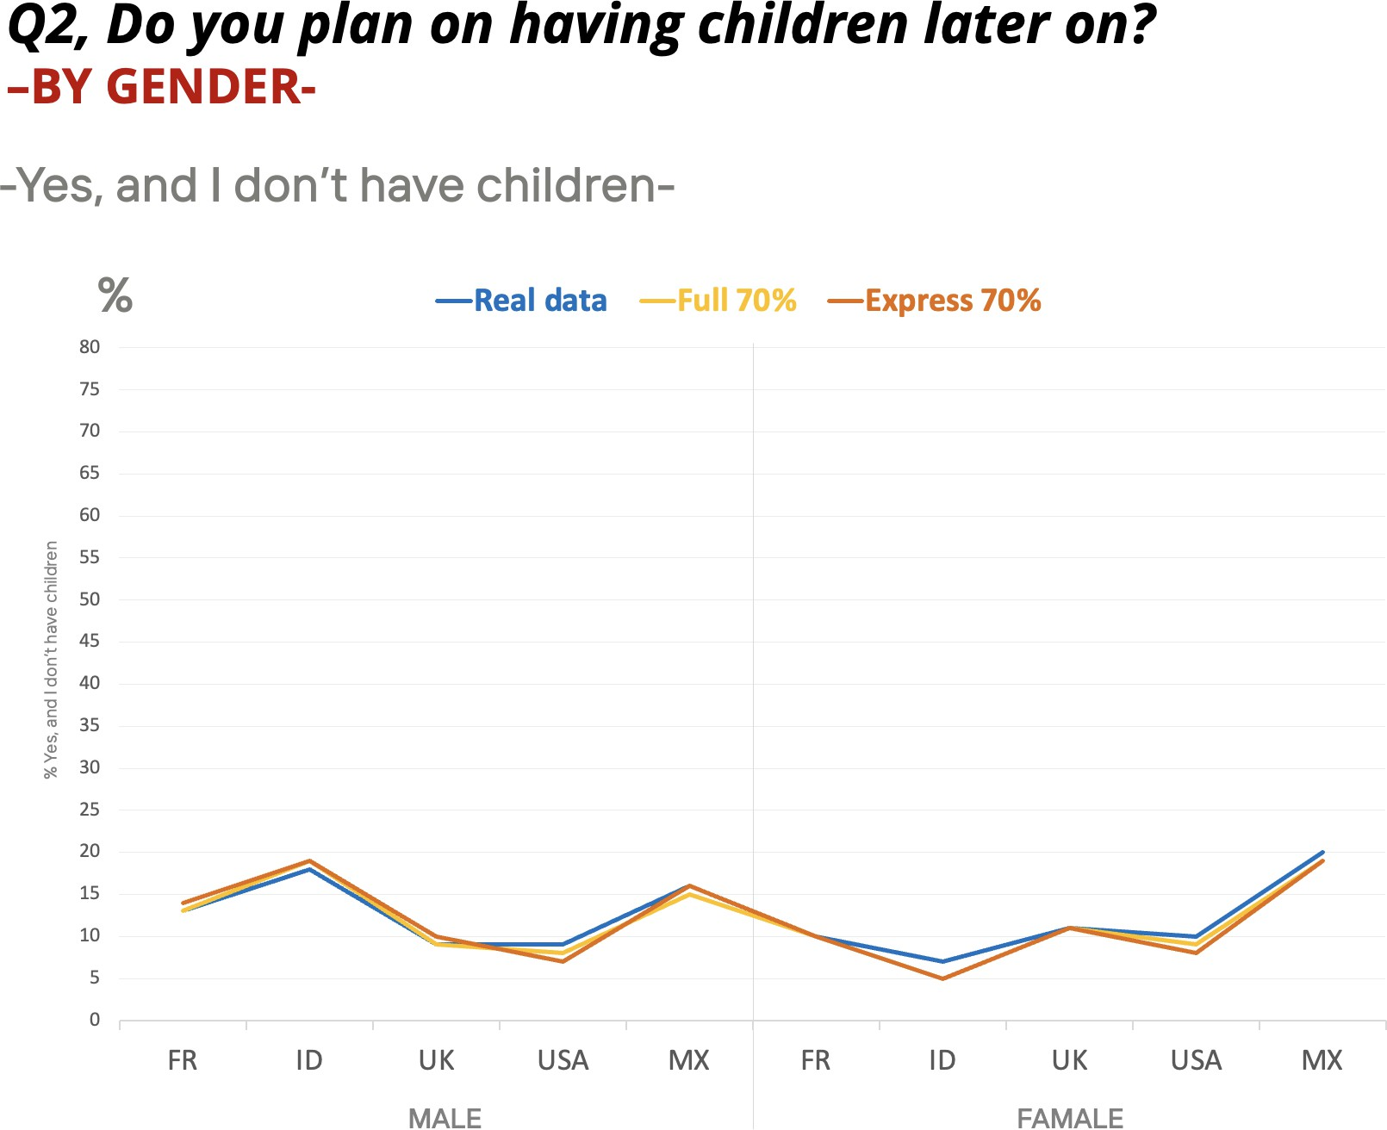

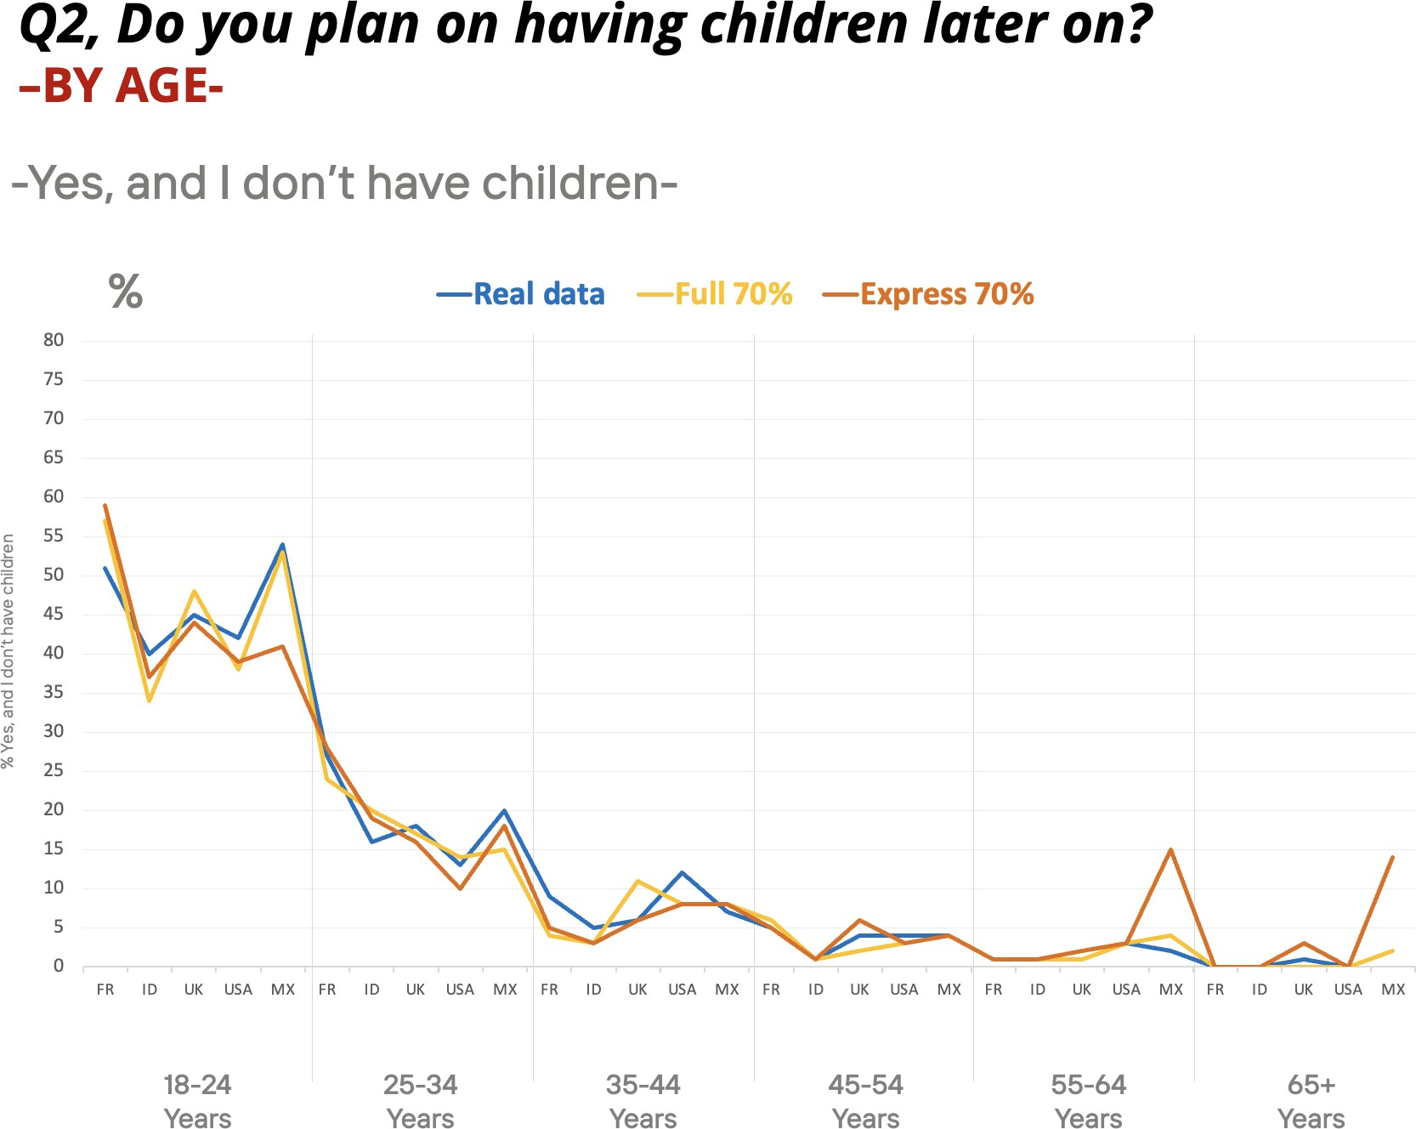

Key Takeaways

- Full 70% is the Most Accurate Model, followed by Express 70%. More Real Data Improves Model Quality.
  - 70% real data outperforms 50% across the board in both augmented and hybrid forms.

Subsample Sensitivity Requires Careful Planning

  - All synthetic models show accuracy degradation in subgroups with less real cases, as it is shown in Mexico when considering older age brackets and males.
  - Hybrid designs mitigate these drops, but do not get accurate numbers.

  - Balance must be planned from fieldwork onward, especially when demographic representation is sparse.
Data augmentation is highly sensitive to the quality and size of the real sample used to feed the algorithm.

Culture is Not a Barrier—If the Right Model is Used

  - Despite differences in response styles and cultural norms, Full 70% and Express 70% hybrids work better across geographies.

